Welcome To
Trinity Lutheran Church
Lutheran Church - Missouri Synod
A Stephen Ministry Congregation

1354 South Otsego Avenue
Gaylord, MI 49735
Church Phone: 989-732-4816

Church Email: secretary@trinitygaylord.com
www.trinitygaylord.com

Office Hours:
Monday through Friday 9am - 1pm

OUR PURPOSE

. . . is to LOVE GOD, LOVE OTHERS AND SERVE THE WORLD by worshiping the Lord Jesus, bringing our members into Christ-like maturity, and equipping them through Word and Sacrament for their mission and ministry. We go heart to heart into the world with Jesus, sharing His love, caring for one another, praying, and bringing the lost into a relationship with Christ, by the working of the Holy Spirit.

April 30, 2023
Fourth Sunday of Easter
Preacher: Rev. Ken Bernthal

ABOUT OUR WORSHIP

We welcome all who gather here today! We are blessed to celebrate together the mercy, grace and love we have from God through the death and resurrection of our Lord Jesus Christ.

Children: Families with children are very welcome here. Having children in church is important so they can begin to learn about their faith in Jesus, and it’s good for the whole congregation to see. Please feel comfortable keeping “squirmy” kids in the service. This is where they belong, too!

Pew cards: Guest and Members, please fill out a Guest/Member card located in the pew rack. The card can be placed in the offering plates at the back of the church.

If standing is difficult feel free to remain seated during any portion of the service. Please let an Elder or Usher know if you need communion in your pew seat.

About our celebration of Holy Communion: We celebrate the Lord’s Supper in the confession and glad confidence that, as he says, our Lord gives into our mouths not only bread and wine but his very body and blood to eat and drink for the forgiveness of sins and to strengthen our union with him and with one another. Our Lord invites to his table those who trust his words, repent of all sin and set aside any refusal to forgive and love as he forgives and loves us, that they may show forth his death until he comes.

Because those who eat and drink our Lord’s body and blood contrary to that which is stated above do so to their great harm, and because Holy Communion is a confession of the faith which is confessed at this altar. Anyone who is not yet instructed, in doubt, or who hold a confession differing from that of the Lutheran Church Missouri Synod, and yet desire to receive the sacrament, are asked to first speak with Pastor. Those not communing are still invited to come forward for a blessing from Pastor, and you may indicate this by crossing your arms over your chest.

Greeting
P Peace be with you.
C And also with you

Divine Service - Setting Four LSB 203

Opening Hymn

710 The Lord’s My Shepherd, I’ll Not Want
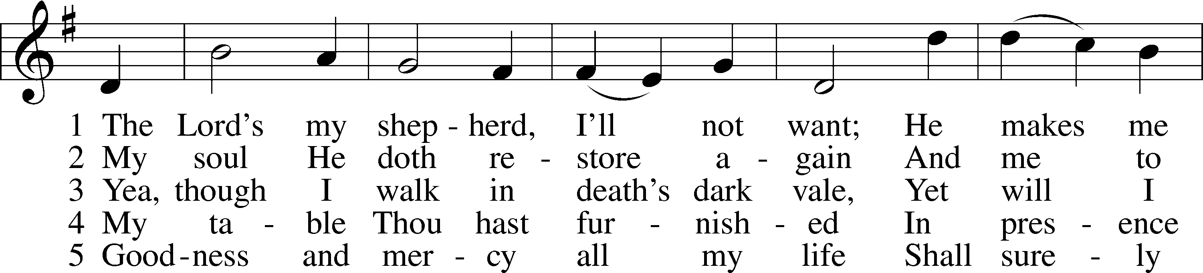
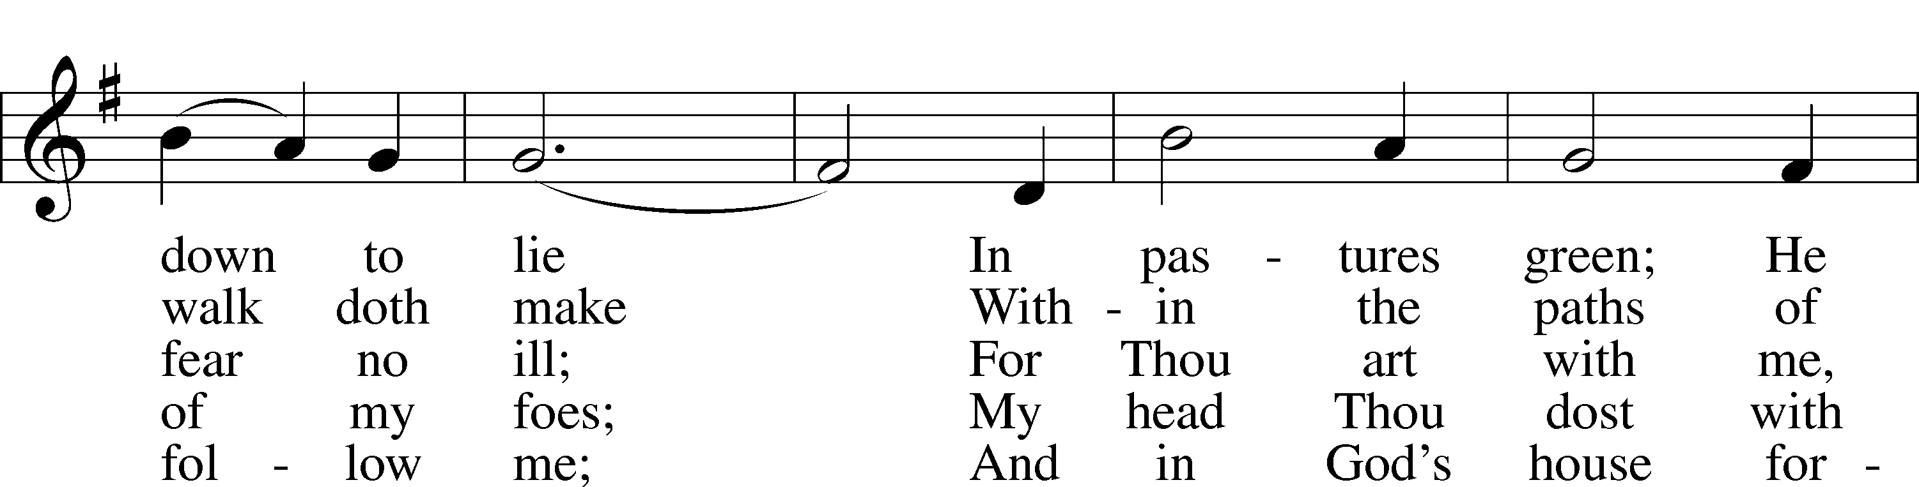
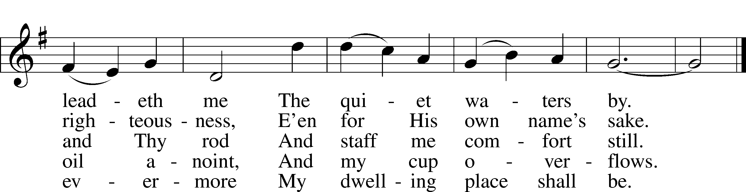

Stand

Confession and Absolution

The sign of the cross may be made by all in remembrance of their Baptism.

Invocation
P In the name of the Father and of the T Son and of the Holy Spirit.
C Amen.

Exhortation LSB 203
P Our help is in the name of the Lord,
C who made heaven and earth.

P If You, O Lord, kept a record of sins, O Lord, who could stand?
C But with You there is forgiveness; therefore You are feared.

P Since we are gathered to hear God’s Word, call upon Him in prayer and praise, and receive the body and blood of our Lord Jesus Christ in the fellowship of this altar, let us first consider our unworthiness and confess before God and one another that we have sinned in thought, word, and deed, and that we cannot free ourselves from our sinful condition. Together as His people let us take refuge in the infinite mercy of God, our heavenly Father, seeking His grace for the sake of Christ, and saying: God, be merciful to me, a sinner.

Confession of Sins LSB 203
C Almighty God, have mercy upon us, forgive us our sins, and lead us to everlasting life. Amen.

Prayer for Forgiveness
P Almighty God, merciful Father, in Holy Baptism You declared us to be Your children and gathered us into Your one, holy Church, in which You daily and richly forgive us our sins and grant us new life through Your Spirit. Be in our midst, enliven our faith, and graciously receive our prayer and praise; through Your Son, Jesus Christ, our Lord.
C Amen.

Service of the Word

Introit
P I am the good shepherd.
C I know my own and my own know me, and I lay down my life for the sheep.
P Oh come, let us sing to the Lord;
C let us make a joyful noise to the rock of our salvation!
P Let us come into his presence with thanksgiving;
C let us make a joyful noise to him with songs of praise!
P For the Lord is a great God,
C and a great King above all gods.
P Oh come, let us worship and bow down;
C let us kneel before the Lord, our Maker!
P For he is our God,
C and we are the people of his pasture, and the sheep of his hand.
A Glory be to the Father and to the Son
and to the Holy Spirit;
as it was in the beginning,
is now, and will be forever. Amen.
P I am the good shepherd.
C I know my own and my own know me, and I lay down my life for the sheep.

Kyrie LSB 204
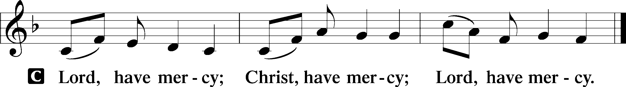

Gloria in Excelsis LSB 204
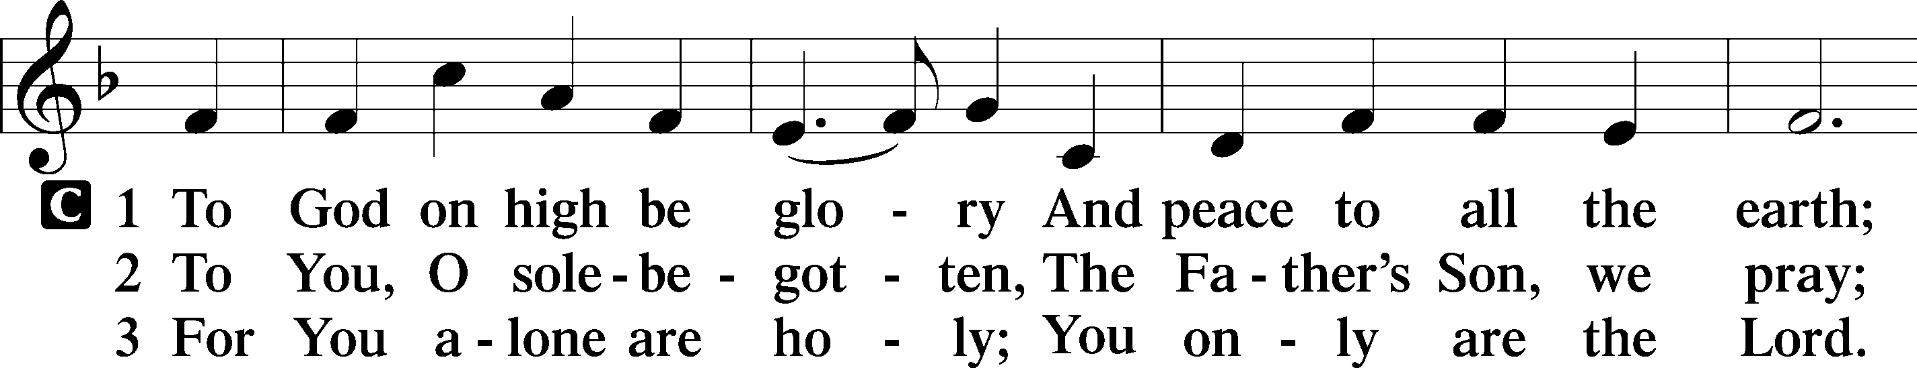
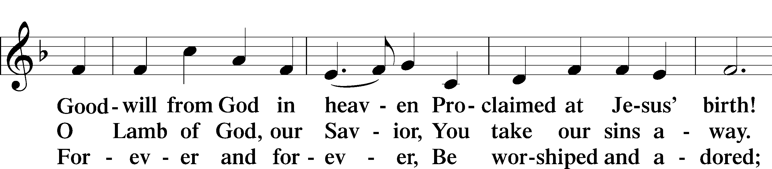
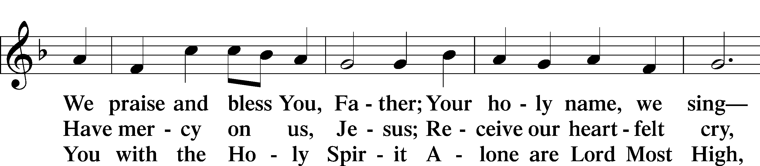
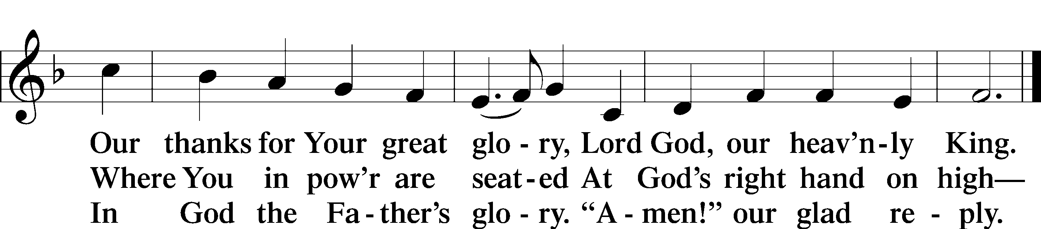

Salutation and Collect of the Day
P The Lord be with you.
C And also with you.

P Let us pray.
Almighty God, merciful Father, since You have wakened from death the Shepherd of Your sheep, grant us Your Holy Spirit that when we hear the voice of our Shepherd we may know Him who calls us each by name and follow where He leads; through the same Jesus Christ, Your Son, our Lord, who lives and reigns with You and the Holy Spirit, one God, now and forever.

C Amen.

Sit

First Reading Acts 2:42–47
42They devoted themselves to the apostles’ teaching and fellowship, to the breaking of bread and the prayers. 43And awe came upon every soul, and many wonders and signs were being done through the apostles. 44And all who believed were together and had all things in common. 45And they were selling their possessions and belongings and distributing the proceeds to all, as any had need. 46And day by day, attending the temple together and breaking bread in their homes, they received their food with glad and generous hearts, 47praising God and having favor with all the people. And the Lord added to their number day by day those who were being saved.

P This is the Word of the Lord.
C Thanks be to God.

Epistle 1 Peter 2:19–25
19This is a gracious thing, when, mindful of God, one endures sorrows while suffering unjustly. 20For what credit is it if, when you sin and are beaten for it, you endure? But if when you do good and suffer for it you endure, this is a gracious thing in the sight of God. 21For to this you have been called, because Christ also suffered for you, leaving you an example, so that you might follow in his steps. 22He committed no sin, neither was deceit found in his mouth. 23When he was reviled, he did not revile in return; when he suffered, he did not threaten, but continued entrusting himself to him who judges justly. 24He himself bore our sins in his body on the tree, that we might die to sin and live to righteousness. By his wounds you have been healed. 25For you were straying like sheep, but have now returned to the Shepherd and Overseer of your souls.

P This is the Word of the Lord.
C Thanks be to God.

Stand

Alleluia and Verse

Alleluia LSB 205
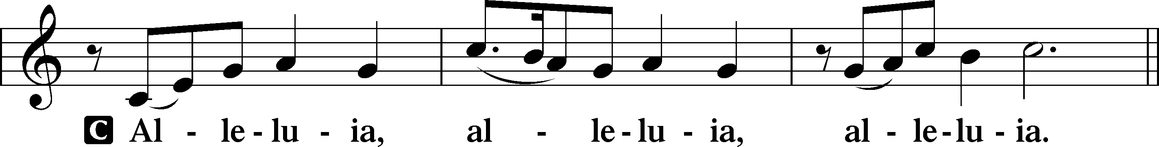

Verse LSB 205
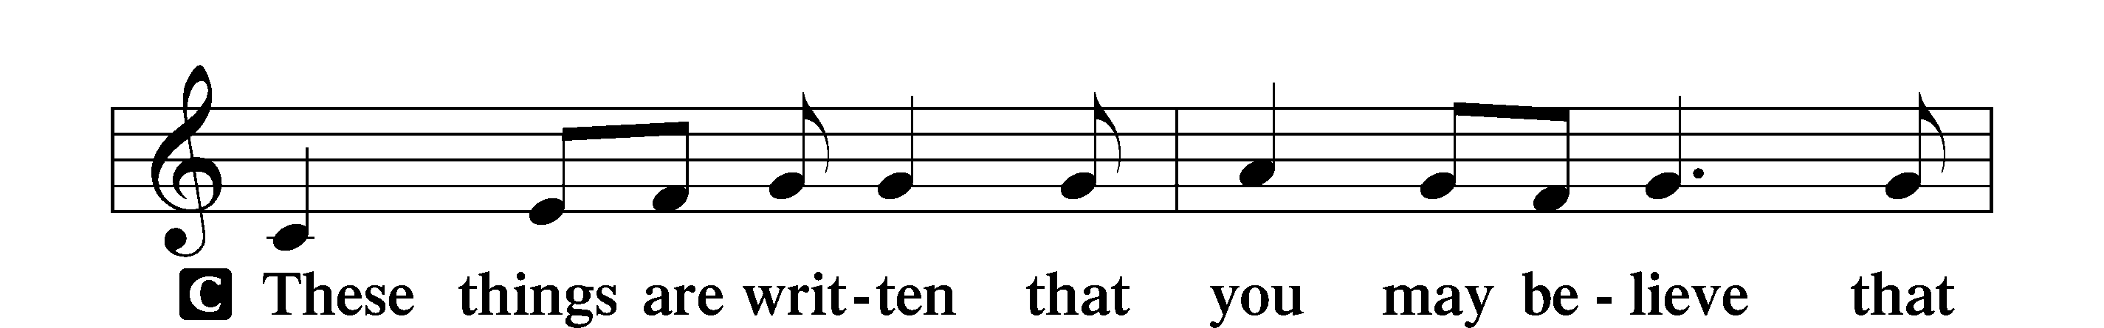
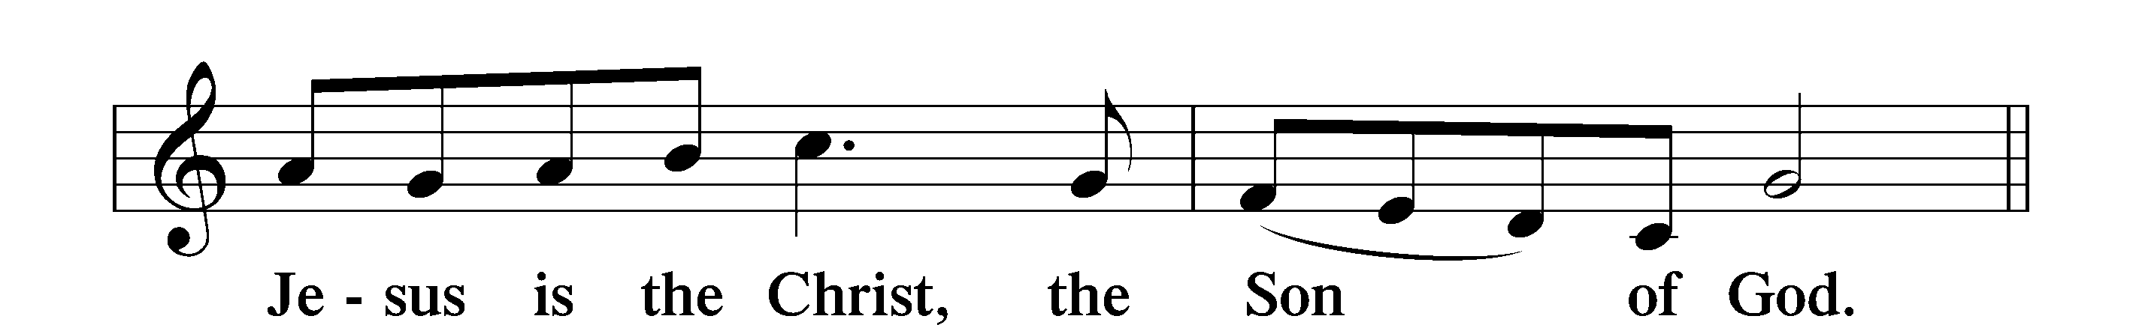

Alleluia LSB 205
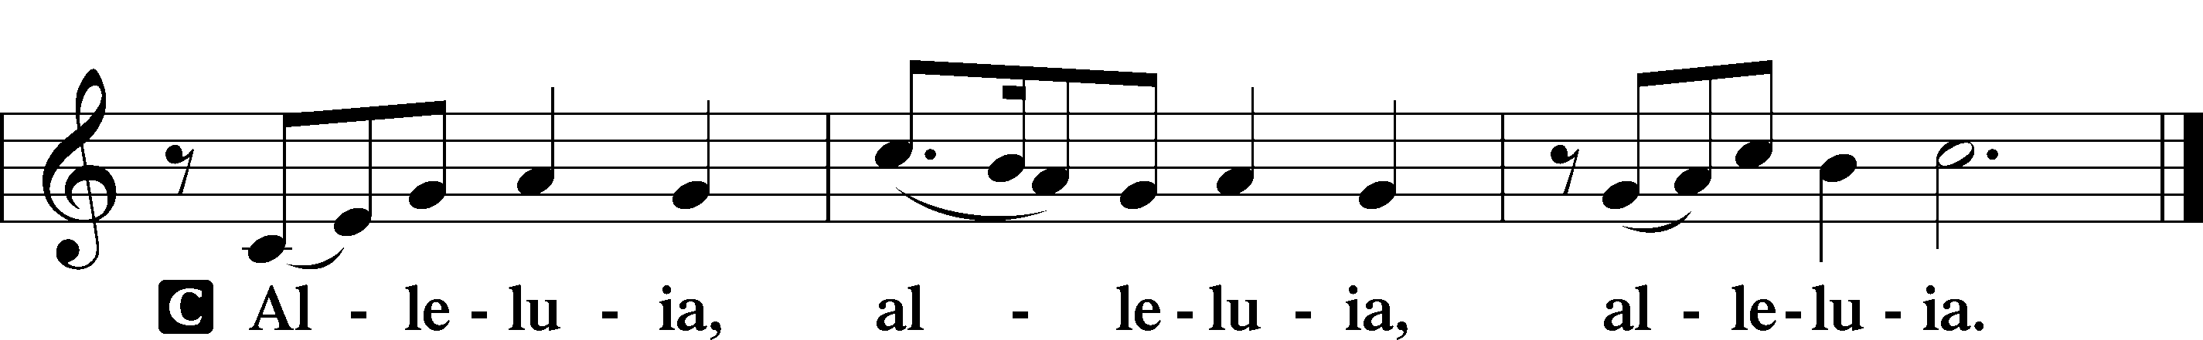

Gospel John 10:1–10
P The Holy Gospel according to St. John, the tenth chapter.
C Glory to You, O Lord.

1[Jesus said:] “Truly, truly, I say to you, he who does not enter the sheepfold by the door but climbs in by another way, that man is a thief and a robber. 2But he who enters by the door is the shepherd of the sheep. 3To him the gatekeeper opens. The sheep hear his voice, and he calls his own sheep by name and leads them out. 4When he has brought out all his own, he goes before them, and the sheep follow him, for they know his voice. 5A stranger they will not follow, but they will flee from him, for they do not know the voice of strangers.” 6This figure of speech Jesus used with them, but they did not understand what he was saying to them.
7So Jesus again said to them, “Truly, truly, I say to you, I am the door of the sheep. 8All who came before me are thieves and robbers, but the sheep did not listen to them. 9I am the door. If anyone enters by me, he will be saved and will go in and out and find pasture. 10The thief comes only to steal and kill and destroy. I came that they may have life and have it abundantly.”

P This is the Gospel of the Lord.
C Praise to You, O Christ.

Nicene Creed
C I believe in one God,
the Father Almighty,
maker of heaven and earth
and of all things visible and invisible.

And in one Lord Jesus Christ,
the only-begotten Son of God,
begotten of His Father before all worlds,
God of God, Light of Light,
very God of very God,
begotten, not made,
being of one substance with the Father,
by whom all things were made;
who for us men and for our salvation came down from heaven
and was incarnate by the Holy Spirit of the virgin Mary
and was made man;
and was crucified also for us under Pontius Pilate.
He suffered and was buried.
And the third day He rose again according to the Scriptures
and ascended into heaven
and sits at the right hand of the Father.
And He will come again with glory to judge both the living and the dead,
whose kingdom will have no end.

And I believe in the Holy Spirit,
the Lord and giver of life,
who proceeds from the Father and the Son,
who with the Father and the Son together is worshiped and glorified,
who spoke by the prophets.
And I believe in one holy Christian and apostolic Church,
I acknowledge one Baptism for the remission of sins,
and I look for the resurrection of the dead
and the life T of the world to come. Amen.

Sit

Children’s Talk

Sermon Hymn

725 Children of the Heavenly Father
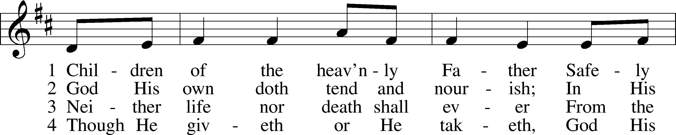
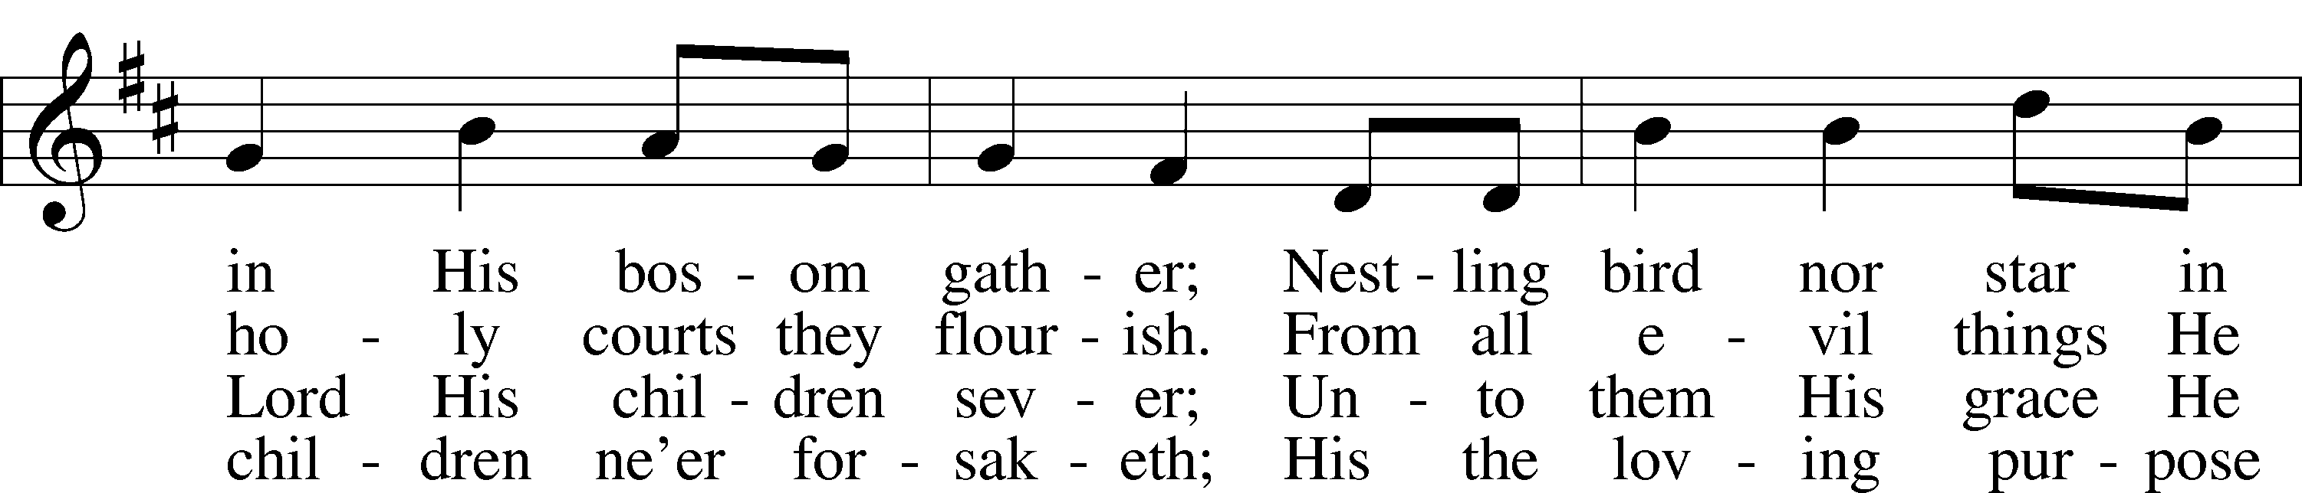
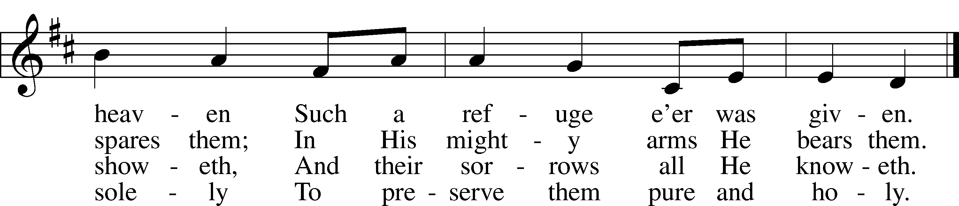

Sermon

Stand

Prayer of the Church

Prayer Response
After each segment:
P Lord, in Your mercy,
C hear our prayer.

After prayers:
P In the name of Jesus we pray.
C Amen.

Service of the Sacrament

Preface 208
P The Lord be with you.
C And also with you.

P Lift up your hearts.
C We lift them to the Lord.

P Let us give thanks to the Lord our God.
C It is right to give Him thanks and praise.

P It is truly good, right, and salutary that we should at all times and in all places give thanks to You, O Lord, holy Father, almighty and everlasting God, for the countless blessings You so freely bestow on us and all creation. Above all, we give thanks for Your boundless love shown to us when You sent Your only-begotten Son, Jesus Christ, into our flesh and laid on Him our sin, giving Him into death that we might not die eternally. Because He is now risen from the dead and lives and reigns to all eternity, all who believe in Him will overcome sin and death and will rise again to new life. Therefore with angels and archangels and with all the company of heaven we laud and magnify Your glorious name, evermore praising You and singing:

Sanctus LSB 208
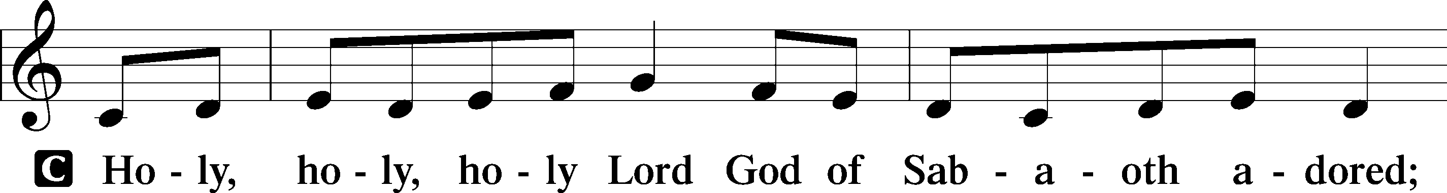
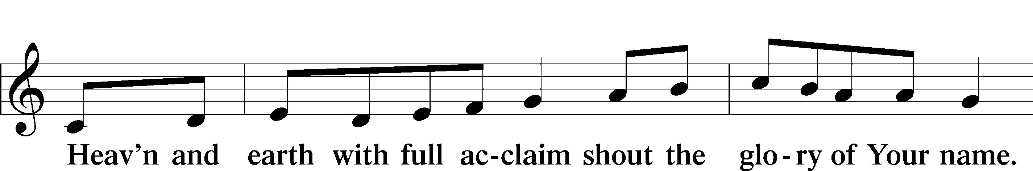
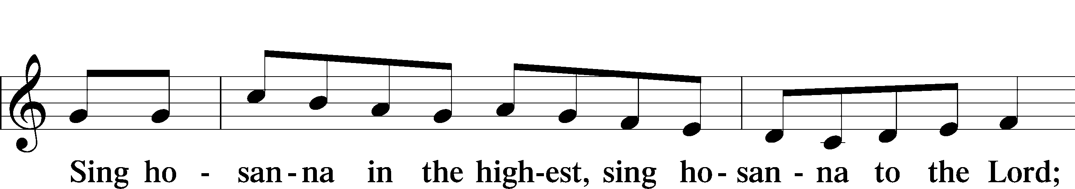
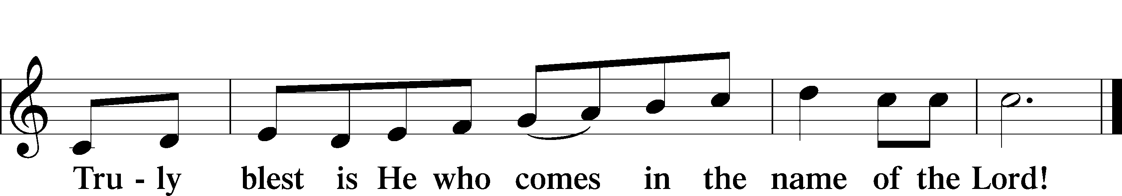

Prayer of Thanksgiving
P Blessed are You, O Lord our God, king of all creation, for You have had mercy on us and given Your only-begotten Son that whoever believes in Him should not perish but have eternal life.

For Christ, our Passover Lamb, has been sacrificed. By His death, He has redeemed us from bondage to sin and death, and by His resurrection, He has delivered us into new life in Him.

Grant us to keep the Feast in sincerity and truth, faithfully eating His body given into death and drinking His life’s blood poured out for our salvation until we pass through death to the promised land of life eternal.

Hear us as we pray in His name and as He has taught us:

Lord’s Prayer
C Our Father who art in heaven,
hallowed be Thy name,
Thy kingdom come,
Thy will be done on earth
as it is in heaven;
give us this day our daily bread;
and forgive us our trespasses
as we forgive those
who trespass against us;
and lead us not into temptation,
but deliver us from evil.
For Thine is the kingdom
and the power and the glory
forever and ever. Amen.

The Words of Our Lord
P Our Lord Jesus Christ, on the night when He was betrayed, took bread, and when He had given thanks, He broke it and gave it to the disciples and said: “Take, eat; this is My T body, which is given for you. This do in remembrance of Me.”

In the same way also He took the cup after supper, and when He had given thanks, He gave it to them, saying: “Drink of it, all of you; this cup is the new testament in My T blood, which is shed for you for the forgiveness of sins. This do, as often as you drink it, in remembrance of Me.”

Pax Domini
P The peace of the Lord be with you always.
C Amen.

Agnus Dei LSB 210
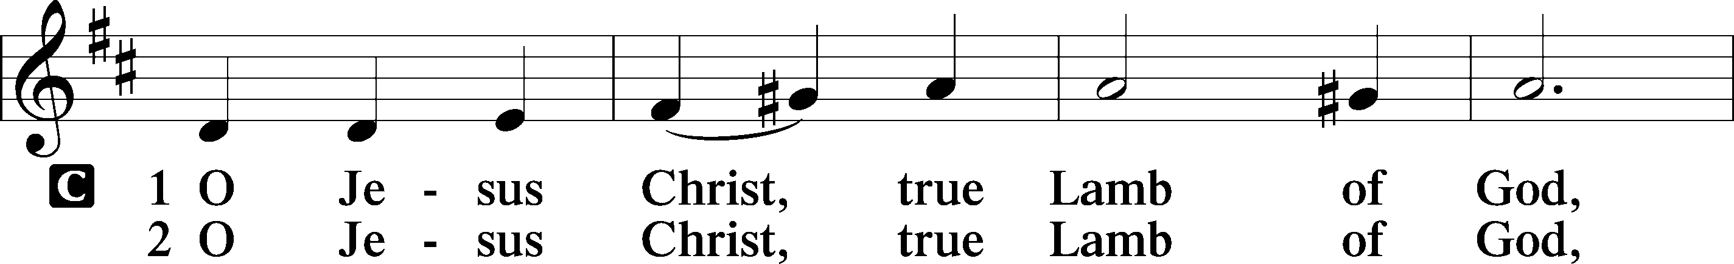
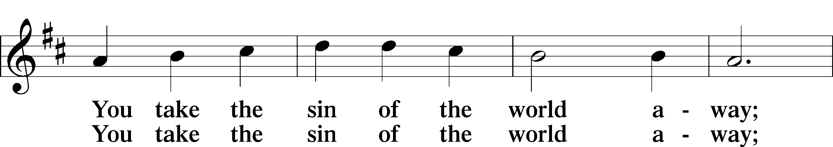
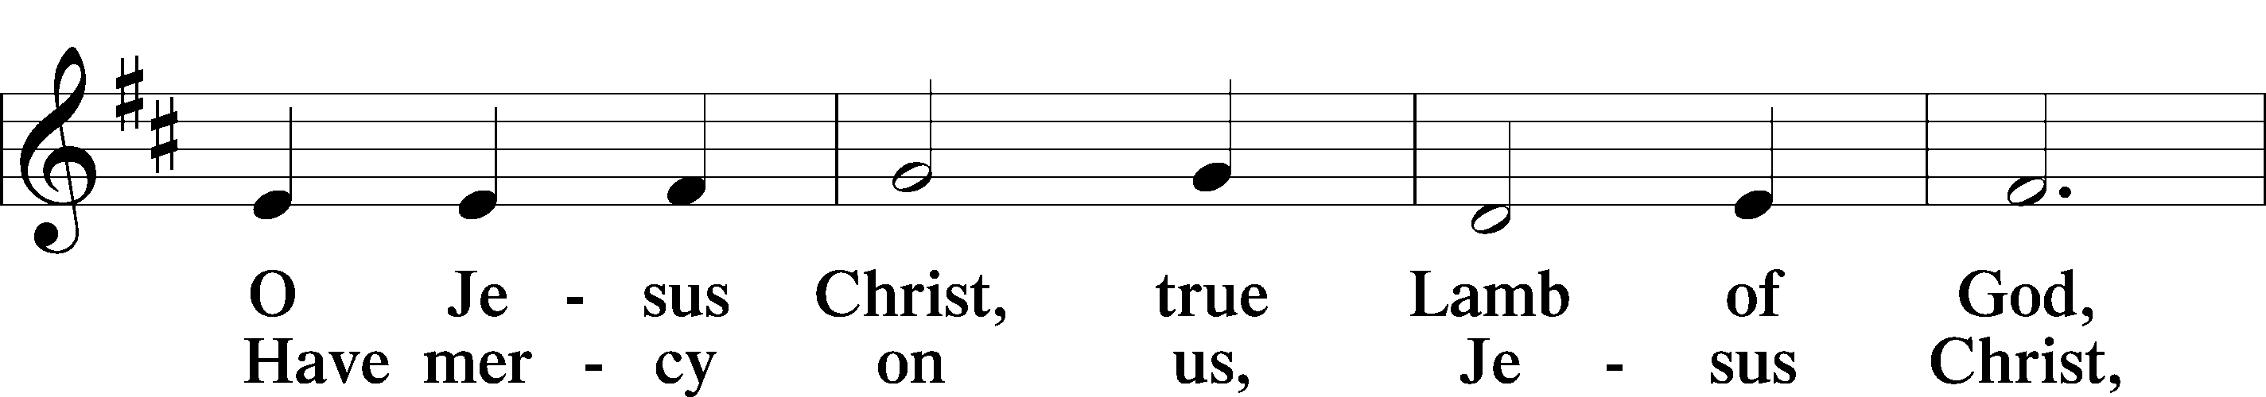
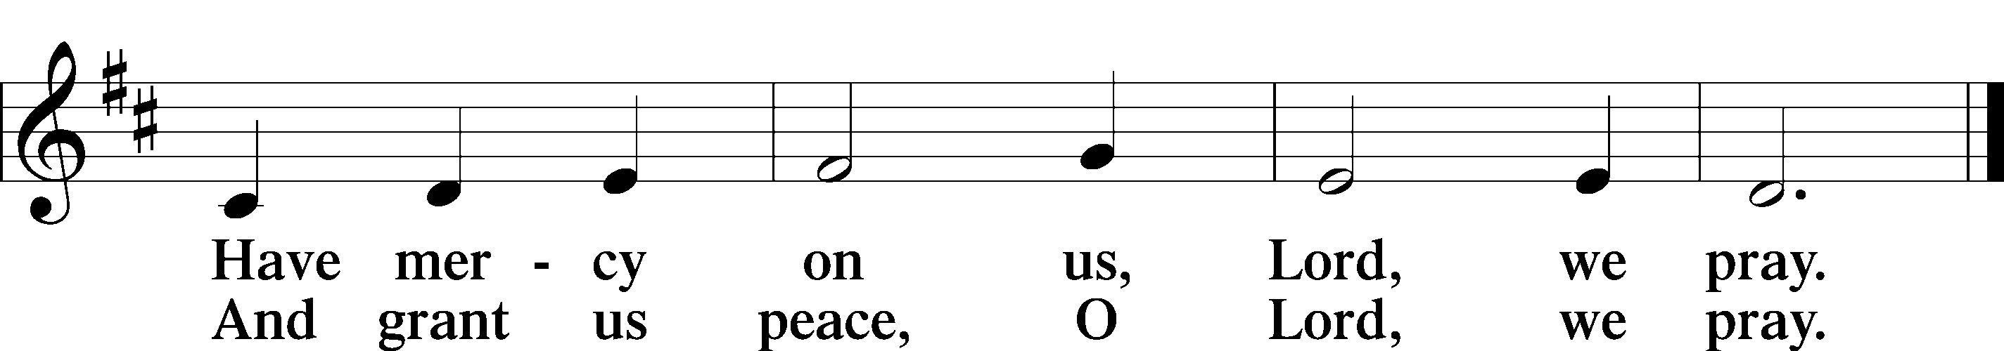

Sit

Distribution Hymns
628 Your Table I Approach
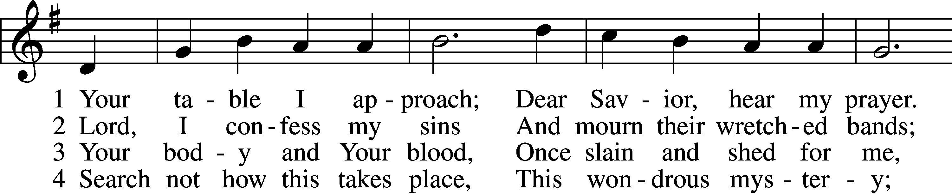
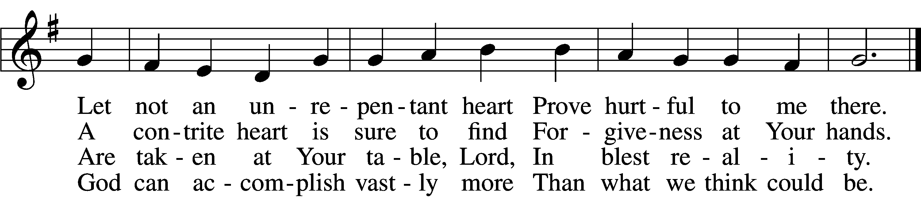

5 O grant, most blessèd Lord,
That earth and hell combined
May not about this sacrament
Raise doubt within my mind.

6 Oh, may I never fail
To thank You day and night
For Your true body and true blood,
O God, my peace and light.

729 I Am Trusting Thee, Lord Jesus
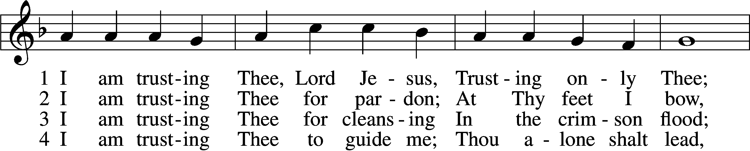
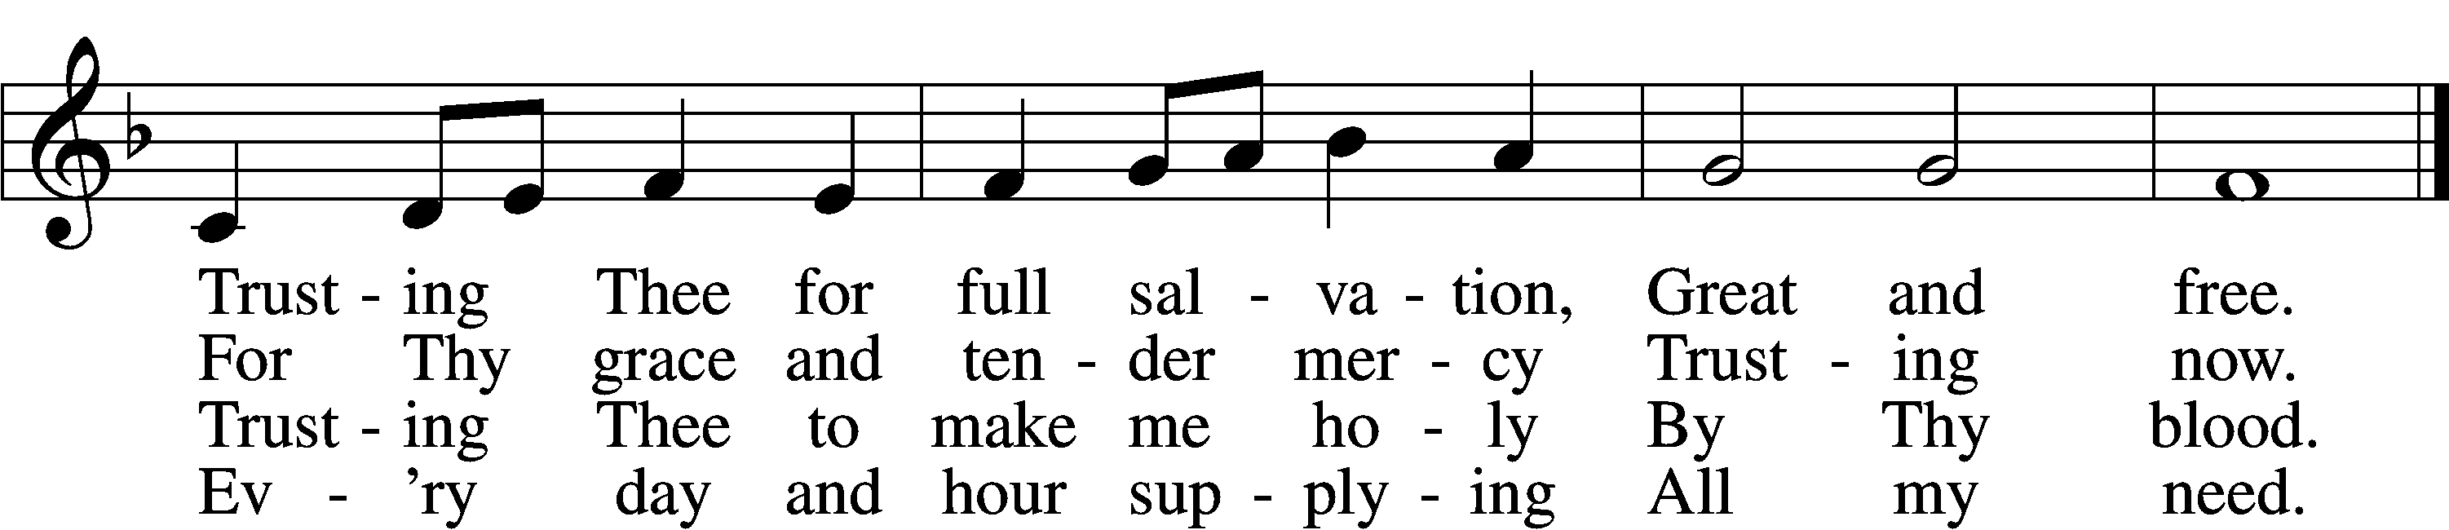

5 I am trusting Thee for power;
Thine can never fail.
Words which Thou Thyself shalt give me
Must prevail.

6 I am trusting Thee, Lord Jesus;
Never let me fall.
I am trusting Thee forever
And for all.

Stand

Nunc Dimittis LSB 211
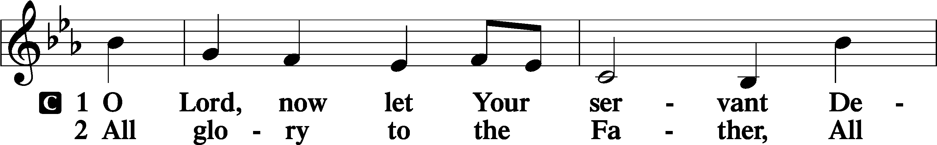
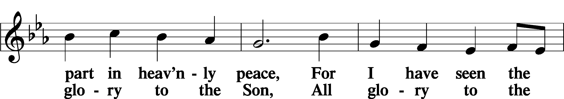
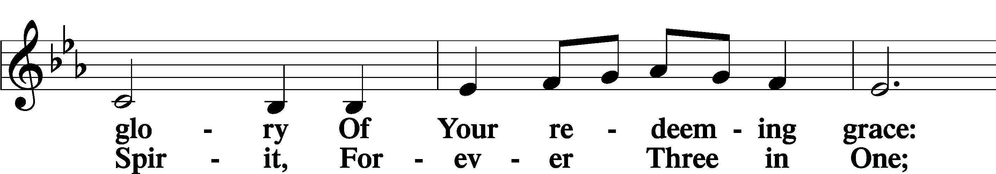
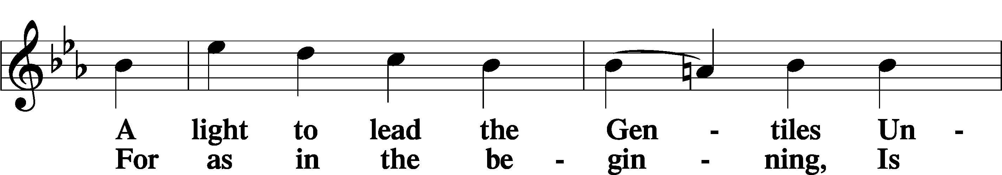
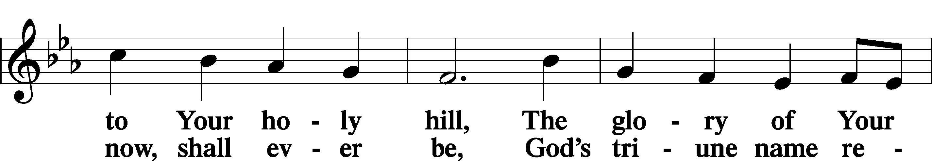
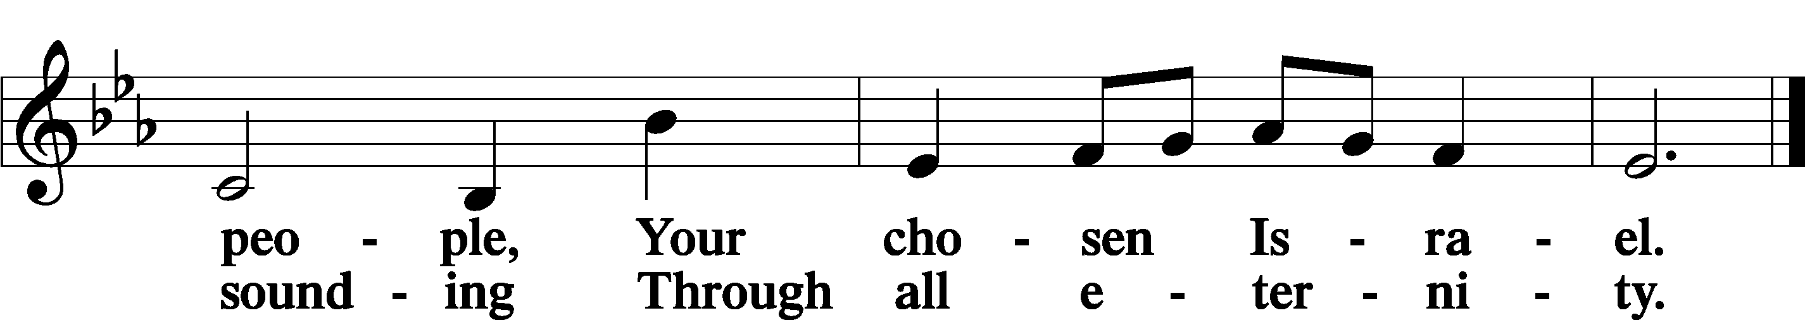

Post-Communion Collect
P Let us pray.
We give thanks to You, almighty God, that You have refreshed us through this salutary gift, and we implore You that of Your mercy You would strengthen us through the same in faith toward You and in fervent love toward one another; through Jesus Christ, Your Son, our Lord, who lives and reigns with You and the Holy Spirit, one God, now and forever.
C Amen.

Benedicamus LSB 212
P Let us bless the Lord.
C Thanks be to God.

Benediction
P The Lord bless you and keep you.
The Lord make His face shine on you and be gracious to you.
The Lord look upon you with favor and T give you peace.
C Amen.

Sit

711 Savior, like a Shepherd Lead Us
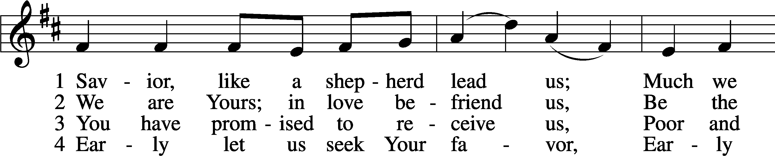
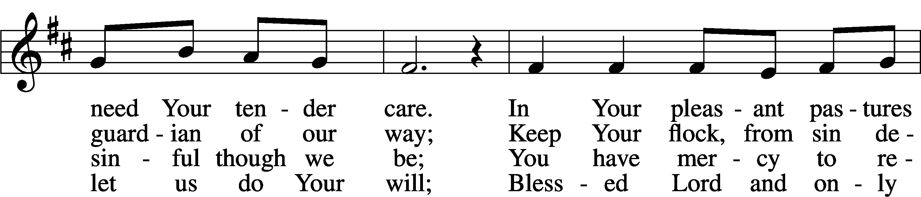
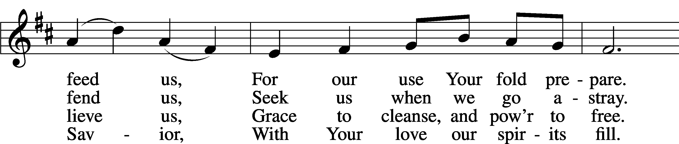
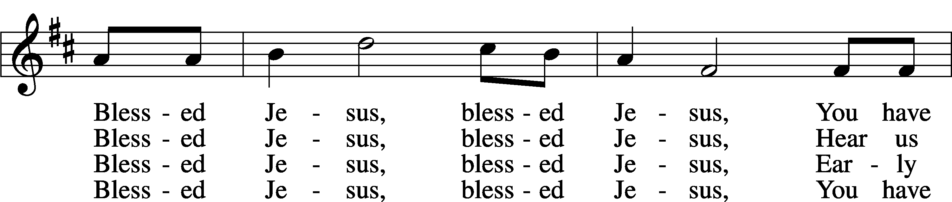
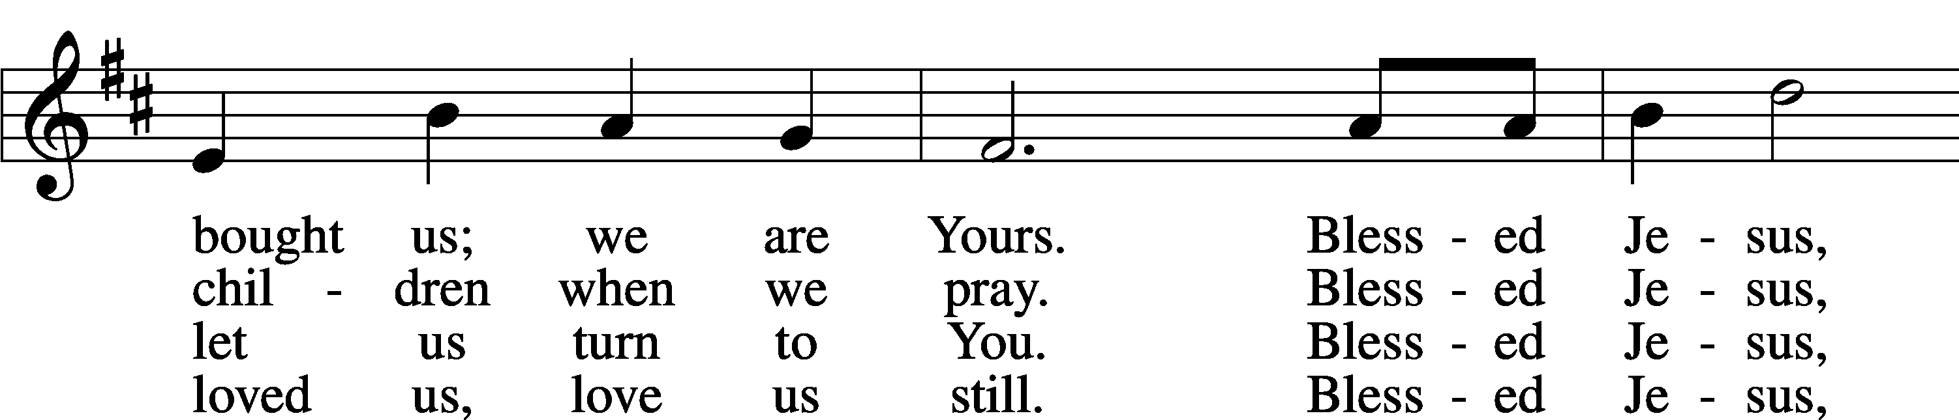
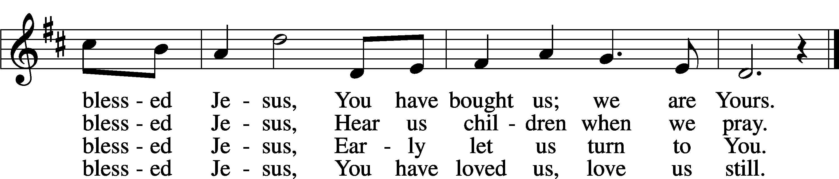

Closing Statement
P We go to live for Jesus.
C We go to share His love.

Acknowledgments
Unless otherwise indicated, Scripture quotations are from the ESV® Bible (The Holy Bible, English Standard Version®), copyright 2001 by Crossway, a publishing ministry of Good News Publishers. Used by permission. All rights reserved. Created by Lutheran Service Builder. Music reproduced in this service is used with permission through: CCLI License No.1776588 and CPH – LSB Service Builder.
.

